**Layer 2**   
Limiting Beliefs

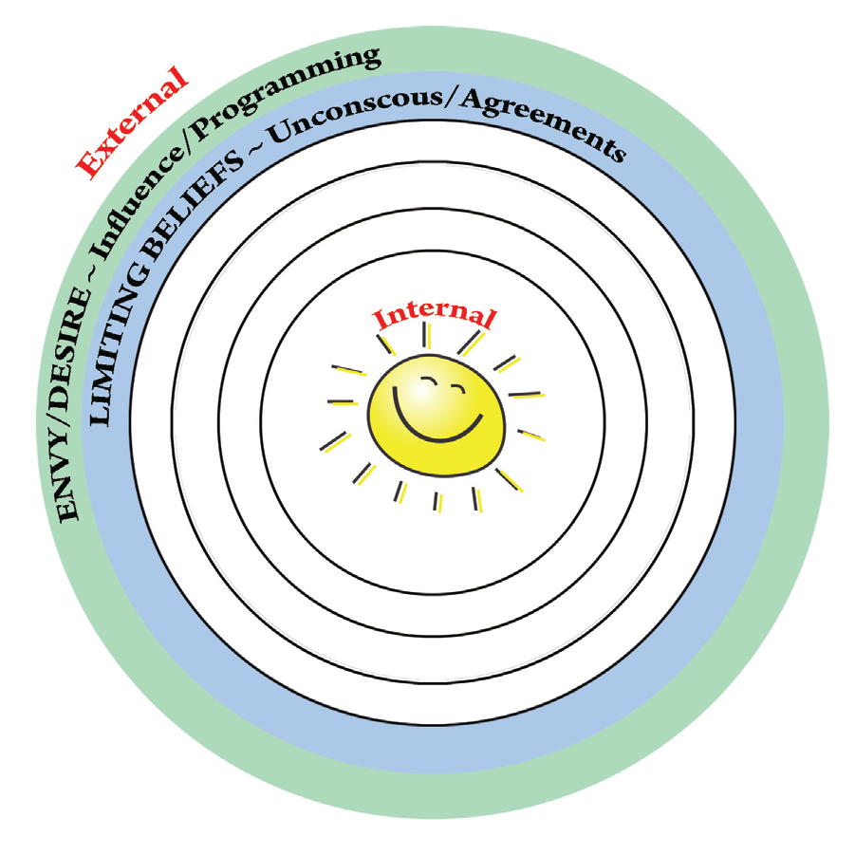

Transformation Services, Inc. | 941-479-0323 | www.TransformationServices.org

**Layer 2: Limiting Beliefs**

We are often unaware of our limiting beliefs because they were “passed down” to us by the attitudes and beliefs of others. As long as they remain unconscious (we are not aware of them) they can hold us back from achieving our fullest potential and experiencing joy. For example, if we have heard all of our life that money is the root of evil then we may unconsciously create situations that limit our financial success out of fear of that evil.

Below is a list of some common “phrases” that we are often told growing up or hear in our community. They are so “normal” that we rarely question their validity or consider how they affect our belief systems or make us unhappy. Of course, there is some truth and a good intention behind most of them, but consider which ones you have been conditioned to believe and how they have impacted your beliefs and your life.

***“Money is the root of all evil.”***   
*Good intention:* money does not bring happiness and can corrupt   
*Conditioned fear:* negative association with having money; it turns you into a bad person *Potential limits:* unconsciously avoiding or sabotaging financial success to avoid the “negative qualities” you believe you’ll develop if you have money

***“Finish your plate. There are starving people in the world.”***   
*Good intention:* don’t be wasteful with food and have compassion for others *Conditioned fear:* food scarcity or guilt for having more opportunity than others *Potential limits:* over eating and health problems or holding yourself back to avoid feeling guilty over having more opportunity than others

***“Money doesn’t grow on trees.”***   
*Good intention:* be intelligent with how you spend your money   
*Conditioned fear:* money scarcity; feeling that there is not enough and it is hard to get *Potential limits:* not believing you can have what you want if it involves having money and therefore not going for it

Transformation Services, Inc. | 941-479-0323 | www.TransformationServices.org

***“Don’t burn your bridges.”***   
*Good intention:* keep good relationships with people who may one day be a resource *Conditioned fear:* apprehension to do what you know is right for you if you feel it will make someone disapprove of or reject you   
*Potential limits:* not making a change or taking an opportunity when it comes out of fear of disappointing, offending, or otherwise burning a bridge

***“No pain no gain.”***   
*Good intention:* the reward is worth the struggle   
*Conditioned fear:* the belief that in order to be successful one must suffer   
*Potential limits:* choosing not to make changes or go for what you want because you feel it will be difficult or painful, holding yourself back from success

***“Life is hard.”***   
*Good intention:* pain and struggle are a normal part of being human   
*Conditioned fear:* there is no hope of you feeling at ease or happy in life   
*Potential limits:* feeling discouraged and hopeless; accepting difficulties or unnecessary suffering because you believe it is normal or expected

***“Honor thy mother and father.”***   
*Good intention:* treat your parents with respect and be grateful for them   
*Conditioned fear:* overly concerned about disappointing your parents or that you will be disowned if you follow your heart   
*Potential limits:* holding yourself back from what you want and know you need to do or who you are because your parents (or others) do not approve

Transformation Services, Inc. | 941-479-0323 | www.TransformationServices.org

***“No one ever said life is fair.”***   
*Good intention:* sometimes things seem unfair, but it is okay   
*Conditioned fear:* you will not get what you deserve and there is no justice in the world *Potential limits:* you may hold yourself back feeling like it will not pay off or you may develop feelings of hopelessness

***“Good things come to those who wait.”***   
*Good intention:* it is important to be patient and it’s worth the wait   
*Conditioned fear:* you have to wait a long time to get what you want   
*Potential limits:* a feeling of impatience due to focusing on the length of time and not doing something you want because it will “take too long”

***“You have to pay your dues.”***   
*Good intention:* it takes effort to get results   
*Conditioned fear:* you will have to suffer in order to be worthy of any pay off *Potential limits:* feeling unworthy, you may not take opportunities or you may punish yourself for rewards and accomplishments you receive with ease

***“Speak only when spoken to.”***   
*Good intentions:* be polite and don’t interrupt   
*Conditioned fear:* apprehension to approach others or speak up   
*Potential limits:* avoidance of activities or circumstances requiring you to be in authority, lead, demand what you want, stand up for what you believe, or speak in front of others

***“Children are meant to be seen and not heard.”***   
*Good intentions:* really, there is no good intention here   
*Conditioned fear:* feelings of being unworthy and low self-esteem   
*Potential limits:* avoidance of being in the spotlight or anything that would make you feel important or valued

Transformation Services, Inc. | 941-479-0323 | www.TransformationServices.org

Which of these phrases were you conditioned to believe?

________________________________________________________________________ ________________________________________________________________________ ________________________________________________________________________ Can you think of others?

________________________________________________________________________ ________________________________________________________________________ ________________________________________________________________________ ________________________________________________________________________

|  |  |  |
| --- | --- | --- |
| Do you believe they are all true? | __Yes | __No |

Can you see any fears you developed because of them?

________________________________________________________________________ ________________________________________________________________________ ________________________________________________________________________

Can you see any way in which they have limited you?

________________________________________________________________________ ________________________________________________________________________ ________________________________________________________________________

Transformation Services, Inc. | 941-479-0323 | www.TransformationServices.org

**Changing Your Perspective by Changing our WORDS!**

Perspective is everything when it comes to how we feel, and the words that we use are critical factors of our perspective. Below are some examples of key words that, if changed, will drastically impact our unconscious minds. The shift may seem small, but it can have a drastic effect on our happiness and our overall motivation.

**Have To vs Get To:**   
What areas in your life do you feel and say “I have to”? For example: “I have to go to work.” Change it to “I get to go to work,” and see how different you feel. Now, change YOUR “have to’s” into “get to’s” and try your new perspective on for size.

I have to:________________________________________________________________ I get to:_________________________________________________________________

I have to:________________________________________________________________ I get to:_________________________________________________________________

I have to:________________________________________________________________ I get to:_________________________________________________________________

**I Can't vs. How Can I?**

What areas do you limit your ability to truly be authentic to what you want and your ability to feel joy? Changing this terminology allows the brain to stop shutting off possibilities and instead look for ways to create the things you desire. What do you feel limited about? Does asking “how can I?” change the way you feel about it?

I can’t:__________________________________________________________________ How can I:_______________________________________________________________

I can’t:__________________________________________________________________ How can I:_______________________________________________________________

Transformation Services, Inc. | 941-479-0323 | www.TransformationServices.org

I can’t:__________________________________________________________________ How can I:_______________________________________________________________

**Changing Your “What if's”!**

Many times we use “What if’s” in a negative way. For example, people say “what if I get fired”, “what if my relationship goes bad”, and so on and so on. These “what if’s” take away our ability to feel joy because they stop us from doing what we really want in life out of fear of “what if”. Try turning your “what if’s” into POSITIVE ones! “What if you get a promotion?” and “what if your relationship improves?” Remember, the unconscious mind is powerful and will LOOK FOR whatever you tell it to look for. By saying “what if something amazing happened?” your mind automatically will begin scanning your life for amazing things!

What negative “what if’s” do you often think? Rewrite new, positive ones below:

What If...

________________________________________________________________________ ________________________________________________________________________ ________________________________________________________________________ What If...

________________________________________________________________________ ________________________________________________________________________ _______________________________________________________________________ What If...

________________________________________________________________________ ________________________________________________________________________ ________________________________________________________________________

Transformation Services, Inc. | 941-479-0323 | www.TransformationServices.org